

Members of the Planning Commission
STAFF REPORT
For the Meeting of October 14, 2026
Title/Subject
Adoption of 2026 Hermiston Transportation System Plan
Summary and Background
The 2026 update to the Hermiston Transportation System Plan (TSP) is ready for adoption. The TSP update constitutes a legislative update to the city’s comprehensive plan and implementing land use ordinances. The update is funded through a TGM (Transportation and Growth Management) grant from the State of Oregon. Grant funds were used to prepare a new TSP with the assistance of Kittelson and Associates as the lead transportation engineers. Kittelson subcontracted with Anderson Perry and Urbsworks for additional assistance with specific work tasks.
Work began in the fall of 2025 on the TSP update. A project management team consisting of city staff, county staff, emergency services, public works staff, ODOT, and interested citizens representing various stakeholder groups all managed the update process providing feedback at all stages. The city also worked to provide a robust public participation process. Two virtual open houses with interactive maps were provided. These virtual open houses provided the public with an opportunity to identify areas of concern in the transportation network and to rate potential solutions to issues. The city held a public open house at a Hermiston High School football game in conjunction with a city council chat event and provided posters for the public to identify areas of concern in person. Two events were held targeting school-aged youth. An elementary school event at Loma Vista elementary provided an interactive transportation education event. High school students were also provided an opportunity for input. City staff and Kittelson staff conducted a second public open house at the Christmas Tree lighting event in 2025. The tree lighting was very well attended and valuable input was submitted on the TSP and potential projects.
The current TSP dates to 1997 and has been amended four times since adoption. The amendments were used to address specific issues arising from development pressures, such as adding new signals to the plan, and to comprehensively update the plan in 2014 as part of a regular review of the entire comprehensive plan. Nevertheless, the Hermiston TSP was created at a time when the city’s population was just 10,000 and the city’s population has doubled to 20,000 and many miles of road have been added to the network. Technology and social needs have also changed in the intervening years. The 1997 plan is no longer reflective of both of community needs nor does it adequately provide a framework for continued growth. Many of the projects have been completed or have been supplanted by other needs. Therefore, this update is intended to entirely repeal the 1997 TSP and adopt and implement this new, 2026 TSP. Uncompleted projects were re-evaluated and carried forward into the new plan where appropriate or removed where no longer necessary. Cost estimates have been updated to reflect current construction costs.
Significant changes are proposed to the TSP over the 1997 plan. A new street classification plan is proposed. This new street classification plan upgrades the classification of several streets and designates new collector streets. As an example, Feedville Road is reclassified from a major collector from Highway 395 to S First Street and a rural collector from S First Street to Highway 207, to a major collector for its entire length within the Hermiston UGB reflecting the growth along the corridor and the 2025 UGB expansion. Figure 10 of the TSP illustrates the updated street classification. Dotted lines on the street classification map indicate the paths of streets which are planned for future construction as growth necessitates.
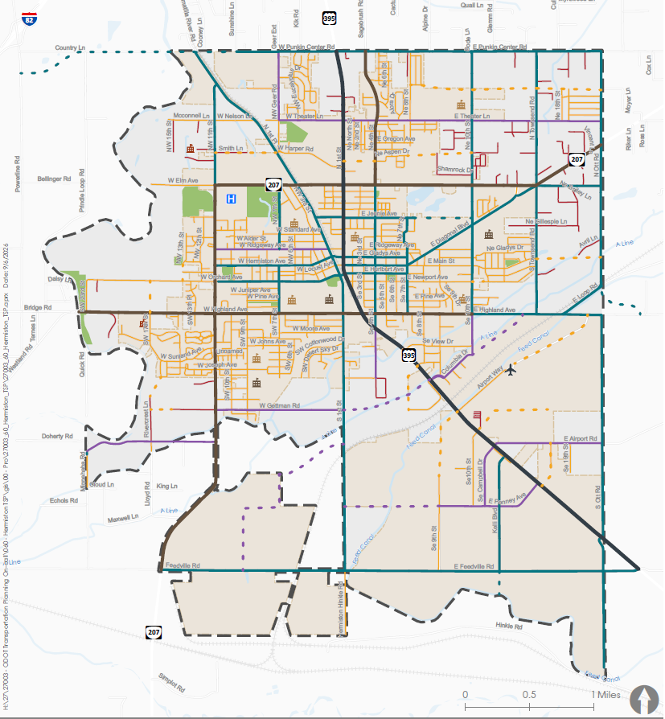
The TSP makes many notable changes to the planned transportation network. The technical memos accompanying the TSP best explain the changes in the network. Tech memo 5 (TM#5) is the in depth planning effort to develop the concept designs for many projects and is an appendix to the TSP in the adoption materials. Table 9 on pages 46 and 47 of TM#5 highlights the majority of major changes in the new TSP. The notable changes include:
- Removing the E Elm Ave Umatilla River bridge based on subsequent engineering work recommending the crossing be located at Punkin Center
- The E Highland/SE 4th St intersection improvements are changed from a signal to a roundabout
- The Highland/S 1st St intersection improvements retain future signal or roundabout improvements but adds in a second phase of safety improvements based upon the 2024 Safety Action Plan
- The W Orchard/S 1st St intersection adds in additional design alternatives to the existing signal plan based upon public input during the TSP development
- Multiple sidewalk improvements are changed to multi-use trails based upon the 2020 Parks Master Plan
- Multiple bicycle improvements are changed to multi-use trails based upon the 2020 Parks Master Plan
- The existing signal plan is changed to an intersection improvement plan to better encompass all intersection projects. The intersection improvement projects are listed on pages 43-48 of the TSP
- The 2026 TSP places a higher priority on planning for multi-modal transportation improvements than previous iterations of the TSP. Pedestrian, bike, trail, and transit projects are all included in this TSP
- A sidewalk improvement list is included per 2026 city council goal 1.5 in Table 6
The 2026 TSP in its entirety is attached to this report. The TSP and technical memos are also presented as exhibits to Ordinance No. 23XX for incorporation into the city comprehensive plan.
As part of the TSP update process the city’s implementing ordinances for the TSP were also considered. Ordinance No. 23XY implements three text amendments detailed in the following paragraphs. It is recommended that changes to the land division and zoning code also be made as part of the adoption process. An amendment to the zoning code in Chapter 157 lowering the threshold for transportation impact studies is proposed. Currently, in the city’s public works standards a development must generate at least 1,000 daily trips before a transportation study is required, unless the city determines that a development is significant and will require a study regardless of the trip threshold. This amendment changes the threshold to a flat threshold of 300 trips. The 1,000 trip threshold in the existing standard is too high to capture impacts from much of the city’s development. At the same time, where staff has discretionary authority to require a study based on perceived impact does not meet the “clear and objective” standard required in state law for development codes for housing development. Therefore, in consultation with the transportation engineers, planning commission, and advisory committee, it was determined that a 300 trip threshold will capture the bulk of large scale development while also not posing an undue burden on small scale residential and commercial projects. The attached Resolution No. 24XX makes a simultaneous amendment to the text of the public works standards.
Two amendments to the land division code in Chapter 154 are also proposed. The subdivision standards currently impose a 600-foot maximum block length. This standard is higher than is considered best practice and does not contribute to pedestrian friendly residential development. After consulting with the consulting team, planning commission, and advisory committee, an amendment lowering the maximum block length to 350 feet is proposed. Similarly, an amendment lowering the maximum length for cul-de-sac streets from 400 to 200 feet is proposed. Both block length and cul-de-sac length may exceed the maximum lengths at the developer’s discretion where a pedestrian path connecting to the adjacent street network is constructed.
A separate appendix is included with the technical memos to the TSP. This appendix includes an additional set of potential updates to the development code for new street standards, street trees, residential development on collector and arterial streets, and other updates to the development code and public works standards which may be desired in the future. These recommendations were developed as part of the grant work program. During the joint city council/planning commission work session in March of 2026 it was determined that the city does not wish to implement these additional transportation changes during the adoption process. However, the unadopted changes are still included for ease of future adoption should priorities change in the future.
Tie-In to Council Goals
1.5 Complete Transportation System Plan Update (will include sidewalks)
Fiscal Information
The grant to develop the updated TSP came from the State of Oregon TGM program and totaled $250,000. The city is obligated to provide a 12% match. The city match has been carefully tracked using in-kind staff time, volunteer time, planning commission and city council time, materials for outreach events, and publication costs. The match totals approximately $30,000 in staff time over the 18 months of project development.
The TSP contains a list of prioritized projects and potential funding sources for those projects. Specific projects identified in the 2025 Safety Action Plan also have budgets developed in TM#5 Attachment C.
Alternatives and Recommendation
Alternatives
The planning commission may choose to:
- Recommend adoption of the TSP and code amendments as drafted
- Recommend the city council amend the TSP and/or code amendments
- Recommend rejection of the TSP and code amendments
Recommended Action/Motion
- Motion to adopt findings of fact in support of TSP adoption
- Motion to recommend the city council adopt the TSP and code amendments as drafted
Submitted By:
Clinton Spencer, Planning Director

